6. Application Layer

**Domain Name System (DNS) in Application Layer**

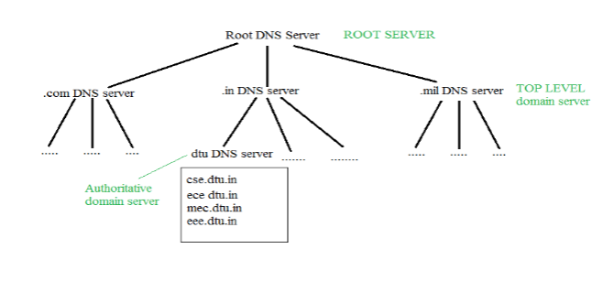DNS is a host name to IP address translation service. DNS is a distributed database implemented in a hierarchy of name servers. It is an application layer protocol for message exchange between clients and servers.

**Requirement**

Every host is identified by the IP address but remembering numbers is very difficult for the people and also the IP addresses are not static therefore a mapping is required to change the domain name to IP address. So DNS is used to convert the domain name of the websites to their numerical IP address.

**Domain:**   
There are various kinds of DOMAIN :

1. Generic domain : .com(commercial) .edu(educational) .mil(military) .org(non profit organization) .net(similar to commercial) all these are generic domain.
2. Country domain .in (india) .us .uk
3. Inverse domain if we want to know what is the domain name of the website. Ip to domain name mapping. So DNS can provide both the mapping for example to find the ip addresses of geeksforgeeks.org then we have to type nslookup [www.geeksforgeeks.org](http://www.geeksforgeeks.org).

Organization of Domain  


It is Very difficult to find out the ip address associated to a website because there are millions of websites and with all those websites we should be able to generate the ip address immediately,  
there should not be a lot of delay for that to happen organization of database is very important.

**Namespace** – Set of possible names, flat or hierarchical . Naming system maintains a collection of bindings of names to values – given a name, a resolution mechanism returns the corresponding value –

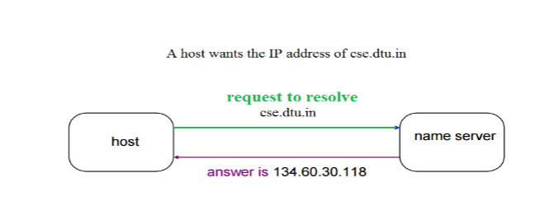

Domain name servers are a fundamental part of the Domain Name System. Nameserver is a server on the Internet specialized in handling queries regarding the location of the domain name’s various services. In easy words, name servers define your domain’s current DNS provider.

**There are three types of queries in the DNS system:**

### Recursive Query

In a recursive query, a DNS client provides a hostname, and the DNS Resolver “must” provide an answer—it responds with either a relevant resource record, or an error message if it can't be found. The resolver starts a recursive query process, starting from the DNS Root Server, until it finds the Authoritative Name Server (for more on Authoritative Name Servers see DNS Server Types below) that holds the IP address and other information for the requested hostname.

### Iterative Query

In an iterative query, a DNS client provides a hostname, and the DNS Resolver returns the best answer it can. If the DNS resolver has the relevant DNS records in its cache, it returns them. If not, it refers the DNS client to the Root Server, or another Authoritative Name Server which is nearest to the required DNS zone. The DNS client must then repeat the query directly against the DNS server it was referred to.

### Non-Recursive Query

A non-recursive query is a query in which the DNS Resolver already knows the answer. It either immediately returns a DNS record because it already stores it in local cache, or queries a DNS Name Server which is authoritative for the record, meaning it definitely holds the correct IP for that hostname. In both cases, there is no need for additional rounds of queries (like in recursive or iterative queries). Rather, a response is immediately returned to the client.

## DNS Types: 4 Types of DNS Servers

The following are the most common DNS server types that are used to resolve hostnames into IP addresses.

* **DNS recursive resolver** - The recursive can be thought of as a librarian who is asked to go find a particular book somewhere in a library. The DNS recursive is a server designed to receive queries from client machines through applications such as web browsers. Typically the recursive is then responsible for making additional requests in order to satisfy the client’s DNS query.
* **Root name server** - The [root server](https://www.cloudflare.com/learning/dns/glossary/dns-root-server/) is the first step in translating (resolving) human readable host names into IP addresses. It can be thought of like an index in a library that points to different racks of books - typically it serves as a reference to other more specific locations.
* [**TLD nameserver**](https://www.cloudflare.com/learning/dns/dns-server-types#tld-nameserver) - The top level domain server (TLD) can be thought of as a specific rack of books in a library. This nameserver is the next step in the search for a specific IP address, and it hosts the last portion of a hostname (In example.com, the TLD server is “com”).
* [**Authoritative nameserve**r](https://www.cloudflare.com/learning/dns/dns-server-types#authoritative-nameserver) - This final nameserver can be thought of as a dictionary on a rack of books, in which a specific name can be translated into its definition. The authoritative nameserver is the last stop in the nameserver query. If the authoritative name server has access to the requested record, it will return the IP address for the requested hostname back to the DNS Recursor (the librarian) that made the initial request.

# HTTP (Hyper Text Transfer Protocol)

The Hypertext Transfer Protocol (HTTP) is application-level protocol for collaborative, distributed, hypermedia information systems. It is the data communication protocol used to establish communication between client and server.

HTTP is TCP/IP based communication protocol, which is used to deliver the data like image files, query results, HTML files etc on the World Wide Web (WWW) with the default port is TCP 80. It provides the standardized way for computers to communicate with each other.

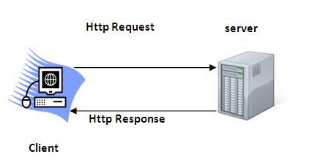

**The Basic Characteristics of HTTP (Hyper Text Transfer Protocol):**

* It is the protocol that allows web servers and browsers to exchange data over the web.
* It is a request response protocol.
* It uses the reliable TCP connections by default on TCP port 80.
* It is stateless means each request is considered as the new request. In other words, server doesn't recognize the user by default.

**The Basic Features of HTTP (Hyper Text Transfer Protocol):**

There are three fundamental features that make the HTTP a simple and powerful protocol used for communication:

* **HTTP is media independent:** It specifies that any type of media content can be sent by HTTP as long as both the server and the client can handle the data content.
* **HTTP is connectionless:** It is a connectionless approach in which HTTP client i.e., a browser initiates the HTTP request and after the request is sent the client disconnects from server and waits for the response.
* **HTTP is stateless:** The client and server are aware of each other during a current request only. Afterwards, both of them forget each other. Due to the stateless nature of protocol, neither the client nor the server can retain the information about different request across the web pages.

**The Basic Architecture of HTTP (Hyper Text Transfer Protocol):**

The below diagram represents the basic architecture of web application and depicts where HTTP stands:

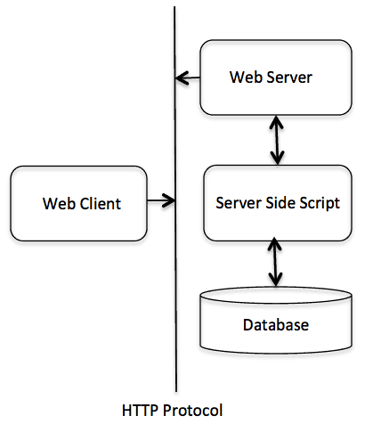

HTTP is request/response protocol which is based on client/server based architecture. In this protocol, web browser, search engines, etc. behave as HTTP clients and the Web server like Servlet behaves as a server

**SMTP**

* SMTP stands for Simple Mail Transfer Protocol.
* SMTP is a set of communication guidelines that allow software to transmit an electronic mail over the internet is called **Simple Mail Transfer Protocol**.
* It is a program used for sending messages to other computer users based on e-mail addresses.
* It provides a mail exchange between users on the same or different computers, and it also supports:
  + It can send a single message to one or more recipients.
  + Sending message can include text, voice, video or graphics.
  + It can also send the messages on networks outside the internet.
* The main purpose of SMTP is used to set up communication rules between servers. The servers have a way of identifying themselves and announcing what kind of communication they are trying to perform. They also have a way of handling the errors such as incorrect email address. For example, if the recipient address is wrong, then receiving server reply with an error message of some kind.

**Model of SMTP system**

In the SMTP model user deals with the user agent (UA) for example Microsoft Outlook, Netscape, Mozilla, etc. In order to exchange the mail using TCP, MTA is used. The users sending the mail do not have to deal with the MTA it is the responsibility of the system admin to set up the local MTA. The MTA maintains a small queue of mails so that it can schedule repeat delivery of mail in case the receiver is not available. The MTA delivers the mail to the mailboxes and the information can later be downloaded by the user agents.

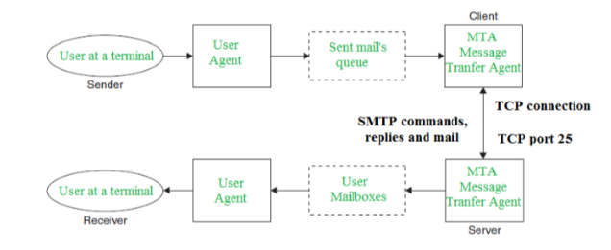

**Communication between sender and the receiver:**   
The senders, user agent prepare the message and send it to the MTA. The MTA functioning is to transfer the mail across the network to the receivers MTA. To send mail, a system must have the client MTA, and to receive mail, a system must have a server MTA.

**SENDING EMAIL:**   
Mail is sent by a series of request and response messages between the client and a server. The message which is sent across consists of a header and the body. A null line is used to terminate the mail header. Everything which is after the null line is considered as the body of the message which is a sequence of ASCII characters. The message body contains the actual information read by the receipt.

**RECEIVING EMAIL:**   
The user agent at the server-side checks the mailboxes at a particular time of intervals. If any information is received it informs the user about the mail. When the user tries to read the mail it displays a list of mails with a short description of each mail in the mailbox. By selecting any of the mail user can view its contents on the terminal.

**Some SMTP Commands:**

* HELO – Identifies the client to the server, fully qualified domain name, only sent once per session
* MAIL – Initiate a message transfer, fully qualified domain of originator
* RCPT – Follows MAIL, identifies an addressee, typically the fully qualified name of the addressee and for multiple addressees use one RCPT for each addressee
* DATA – send data line by line

# FTP

* FTP stands for File transfer protocol.
* FTP is a standard internet protocol provided by TCP/IP used for transmitting the files from one host to another.
* It is mainly used for transferring the web page files from their creator to the computer that acts as a server for other computers on the internet.
* It is also used for downloading the files to computer from other servers.

## Objectives of FTP

* It provides the sharing of files.
* It is used to encourage the use of remote computers.
* It transfers the data more reliably and efficiently.

## Why FTP?

Although transferring files from one system to another is very simple and straightforward, but sometimes it can cause problems. For example, two systems may have different file conventions. Two systems may have different ways to represent text and data. Two systems may have different directory structures. FTP protocol overcomes these problems by establishing two connections between hosts. One connection is used for data transfer, and another connection is used for the control connection.

## Mechanism of FTP

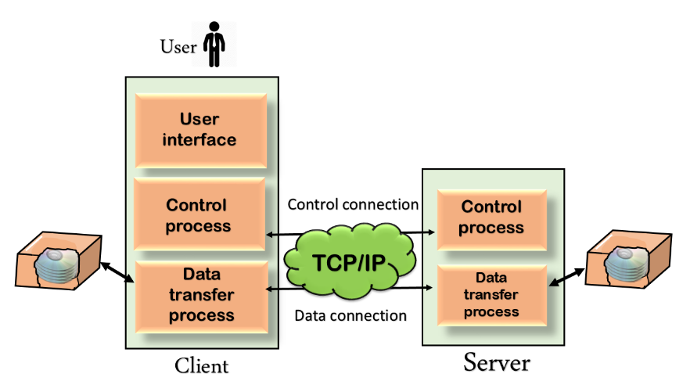

The above figure shows the basic model of the FTP. The FTP client has three components: the user interface, control process, and data transfer process. The server has two components: the server control process and the server data transfer process.

**There are two types of connections in FTP:**

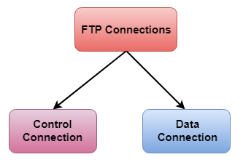

* **Control Connection:** The control connection uses very simple rules for communication. Through control connection, we can transfer a line of command or line of response at a time. The control connection is made between the control processes. The control connection remains connected during the entire interactive FTP session.
* **Data Connection:** The Data Connection uses very complex rules as data types may vary. The data connection is made between data transfer processes. The data connection opens when a command comes for transferring the files and closes when the file is transferred.

## FTP Clients

* FTP client is a program that implements a file transfer protocol which allows you to transfer files between two hosts on the internet.
* It allows a user to connect to a remote host and upload or download the files.
* It has a set of commands that we can use to connect to a host, transfer the files between you and your host and close the connection.
* The FTP program is also available as a built-in component in a Web browser. This GUI based FTP client makes the file transfer very easy and also does not require to remember the FTP commands.

### Advantages of FTP:

* **Speed:** One of the biggest advantages of FTP is speed. The FTP is one of the fastest way to transfer the files from one computer to another computer.
* **Efficient:** It is more efficient as we do not need to complete all the operations to get the entire file.
* **Security:** To access the FTP server, we need to login with the username and password. Therefore, we can say that FTP is more secure.
* **Back & forth movement:** FTP allows us to transfer the files back and forth. Suppose you are a manager of the company, you send some information to all the employees, and they all send information back on the same server.

### Disadvantages of FTP:

* The standard requirement of the industry is that all the FTP transmissions should be encrypted. However, not all the FTP providers are equal and not all the providers offer encryption. So, we will have to look out for the FTP providers that provide encryption.
* FTP serves two operations, i.e., to send and receive large files on a network. However, the size limit of the file is 2GB that can be sent. It also doesn't allow you to run simultaneous transfers to multiple receivers.
* Passwords and file contents are sent in clear text that allows unwanted eavesdropping. So, it is quite possible that attackers can carry out the brute force attack by trying to guess the FTP password.
* It is not compatible with every system.

## Telnet

Telnet is a simple, text-based network protocol that is used for accessing remote computers over TCP/IP networks like the Internet. Telnet was created and launched in 1969 and, historically speaking, you can say that it was the first Internet.

In the old days, you had to physically walk to a server in order to access its data. This meant, among other things, that you had to spend some time arriving at the server's location and then you had to wait for your turn to work with the server. Even if the server had the hardware power to do multiple things at the same time, you were blocked from using it at its full and you had to wait for others to finish their work first. In many circumstances you couldn't even touch the actual server. You had to hand your card stack to an attendant and come back later for your printout.

Telnet brought extraordinary change. Using it meant you could simultaneously connect multiple users to a single server. In order to connect to the server, people only needed access to a terminal, which could be the simplest and cheapest computer available. This computer didn't need to have powerful hardware, it only needed a network connection and a text based interface. Basically, their Telnet Client was like a Command Prompt that people could use in order to work with their servers. This brought a huge boost in productivity.

## What are the Telnet Client & the Telnet Server from Windows?

In Windows, you can add two Telnet related features:

* **Telnet Server** - if you install this feature, you will be able to configure your Windows computer to run as a Telnet server. This means that your computer will listen for incoming connections and allow others to use it. If you're not beneath a firewall and you have a public IP address, anyone in the world will be able to remote control your computer using a Telnet Client.
* **Telnet Client** - this will enable you to connect through Telnet to any server of this type, using just a Command Prompt window.

## How Does Telnet Work?

Telnet originally was used on terminals. These computers require only a keyboard because everything on the screen displays as text. The terminal provides a way to remotely log on to another device, just as if you were sitting in front of it and using it like any other computer.

Nowadays, Telnet can be used from a virtual terminal, or a terminal emulator, which is essentially a modern computer that communicates with the same Telnet protocol. One example of this is the telnet command, available from the Command Prompt in Windows. The telnet command uses the Telnet protocol to communicate with a remote device or system.

Telnet commands can also be executed on other operating systems such as Linux and macOS, in the same way that telnet commands are executed in Windows.

Telnet isn't the same as other TCP/IP protocols such as HTTP, which transfers files to and from a server. Instead, the Telnet protocol has you log on to a server as if you were an actual user, then grants you direct control and all the same rights to files and applications as the user that you're logged in as.

**DHCP**

Dynamic Host Configuration Protocol (DHCP) is a network management protocol used to dynamically assign an IP address to nay device, or node, on a network so they can communicate using IP (Internet Protocol). DHCP automates and centrally manages these configurations. There is no need to manually assign IP addresses to new devices. Therefore, there is no requirement for any user configuration to connect to a DHCP based network.

DHCP can be implemented on local networks as well as large enterprise networks. DHCP is the default protocol used by the most routers and networking equipment. DHCP is also called RFC (Request for comments) 2131.

### DHCP does the following:

* DHCP manages the provision of all the nodes or devices added or dropped from the network.
* DHCP maintains the unique IP address of the host using a DHCP server.
* It sends a request to the DHCP server whenever a client/node/device, which is configured to work with DHCP, connects to a network. The server acknowledges by providing an IP address to the client/node/device.

DHCP is also used to configure the proper subnet mask, default gateway and DNS server information on the node or device.

There are many versions of DCHP are available for use in IPV4 (Internet Protocol Version 4) and IPV6 (Internet Protocol Version 6).

## How DHCP works

DHCP runs at the application layer of the TCP/IP protocol stack to dynamically assign IP addresses to DHCP clients/nodes and to allocate TCP/IP configuration information to the DHCP clients. Information includes subnet mask information, default gateway, IP addresses and domain name system addresses.

DHCP is based on client-server protocol in which servers manage a pool of unique IP addresses, as well as information about client configuration parameters, and assign addresses out of those address pools.

### The DHCP lease process works as follows:

* First of all, a client (network device) must be connected to the internet.
* DHCP clients request an IP address. Typically, client broadcasts a query for this information.
* DHCP server responds to the client request by providing IP server address and other configuration information. This configuration information also includes time period, called a lease, for which the allocation is valid.
* When refreshing an assignment, a DHCP clients request the same parameters, but the DHCP server may assign a new IP address. This is based on the policies set by the administrator.

## Components of DHCP

When working with DHCP, it is important to understand all of the components. Following are the list of components:

* **DHCP Server:** DHCP server is a networked device running the DCHP service that holds IP addresses and related configuration information. This is typically a server or a router but could be anything that acts as a host, such as an SD-WAN appliance.
* **DHCP client:** DHCP client is the endpoint that receives configuration information from a DHCP server. This can be any device like computer, laptop, IoT endpoint or anything else that requires connectivity to the network. Most of the devices are configured to receive DHCP information by default.
* **IP address pool:** IP address pool is the range of addresses that are available to DHCP clients. IP addresses are typically handed out sequentially from lowest to the highest.
* **Subnet:** Subnet is the partitioned segments of the IP networks. Subnet is used to keep networks manageable.
* **Lease:** Lease is the length of time for which a DHCP client holds the IP address information. When a lease expires, the client has to renew it.
* **DHCP relay:** A host or router that listens for client messages being broadcast on that network and then forwards them to a configured server. The server then sends responses back to the relay agent that passes them along to the client. DHCP relay can be used to centralize DHCP servers instead of having a server on each subnet.

## Benefits of DHCP

There are following benefits of DHCP:

**Centralized administration of IP configuration:** DHCP IP configuration information can be stored in a single location and enables that administrator to centrally manage all IP address configuration information.

**Dynamic host configuration:** DHCP automates the host configuration process and eliminates the need to manually configure individual host. When TCP/IP (Transmission control protocol/Internet protocol) is first deployed or when IP infrastructure changes are required.

**Seamless IP host configuration:** The use of DHCP ensures that DHCP clients get accurate and timely IP configuration IP configuration parameter such as IP address, subnet mask, default gateway, IP address of DND server and so on without user intervention.

**Flexibility and scalability:** Using DHCP gives the administrator increased flexibility, allowing the administrator to move easily change IP configuration when the infrastructure changes.

.